- The workflow for inventory needs to configured in BOMS. Contact CIP if you need assistance establishing the workflow.
  - The designated official is determined by your office’s internal policy. This report is for adjusting the financial records to show the correct asset and depreciation values. It is not a certification that a physical inventory was taken.

- Log in to BOMS and select the Inventory Module

- Go to Administration- Year-End Closing function
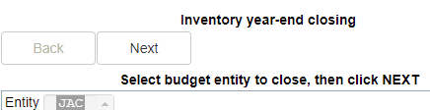

- Select all state-funded Budget Entity options, then click Next. You may select more than one.

- Select the active OCO groups for your office, then click Next. Do not select groups for attractive items (non-OCO).

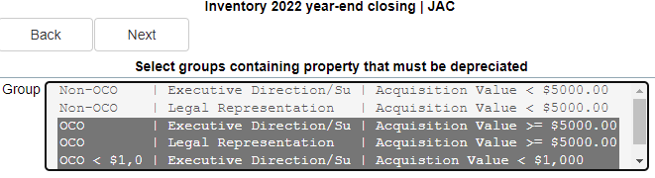
- Select Subgroups, if applicable, then click Next.

- Select all applicable Asset Classes, then click Next.

- Review and verify all Asset Classes to depreciate are shown, then click Next.

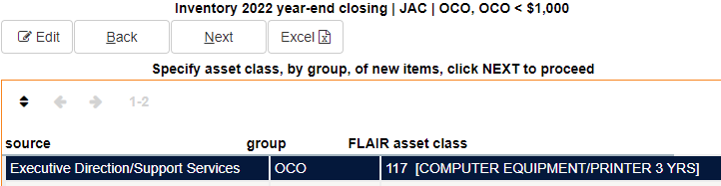

- The items received and placed into inventory this year will display. Please review the items, and if correct, then click Next.
  - If the list is incorrect, exit the process, make the necessary corrections, and begin the process again.

- The items disposed of from the inventory this year will display. Please review the disposals, and if correct, click Next. Ensure that all sales proceeds are shown for applicable assets sold.
  - If the list is incorrect, exit the process, correct the records, and begin the report again.

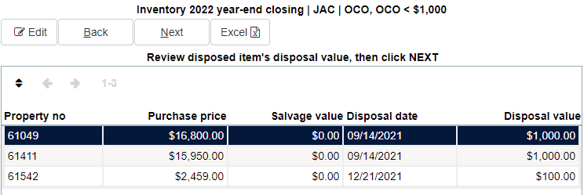

- Review the Transactions Table for accuracy. This table contains all the activity for each inventory item for the year and is the foundation data for the inventory report. It includes additions, deletions, prior and current depreciation, and Gains or Losses. It is best practice to export this data to Excel and save it as support for the Inventory Summary. This is important for future audits. It can’t be regenerated later.

If the transaction list looks correct, then click Next.

- The old-style report will be displayed on the screen. At this point in the process, the Excel version of the report is not available
  - Review the displayed report for issues such as:
    - Verify that your beginning total from this fiscal year matches the ending balance from the last fiscal year.
      - If the totals don’t match, click the back buttons, check the additions and deletions first, and then look at the detailed report. If you cannot identify the cause of the discrepancy, call CIP and ask them to help. They can help identify what happened to cause the problem.
      - If the discrepancy is expected, such as an item was left off inventory for the prior fiscal year and then added to the system, when it is added, BOMS calculates the depreciation from the date it was received. Please include an explanation for the discrepancy as part of your report submission.
    - Verify that the Total Depreciation shown in the last column does not exceed the 6/30/2022 balance.
  - Leave to the report and correct any issues, then repeat the process.
  - When appropriate, select Submit.
  - Select Yes when you are ready to close the year. This will submit the year-end closing paperwork to the next step in the workflow to be approved

- Select the Post and Approve button to submit the report for signature.
  - The designated official will receive an email to sign the inventory report.
  - You will receive an email when the designated official has signed the document.
  - To print the report, select Activities and select Post Inventory Form. The report will be shown on the following screen when approved.
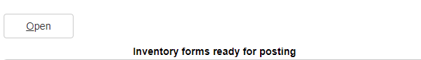

  - Select the download button in the middle of the screen, and save the file.
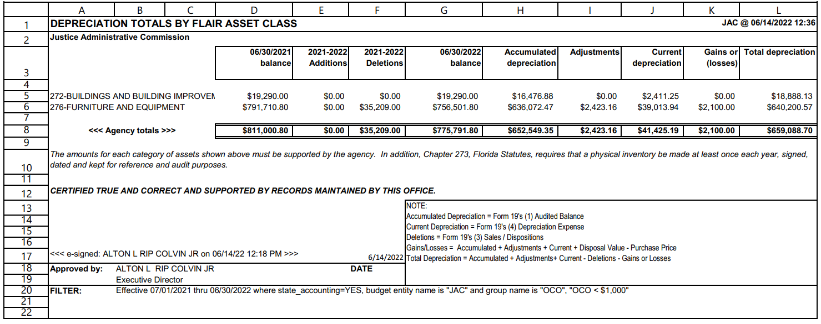
  - Select the Inventory Form, then select Post or Post and Email. (JAC could not get the email function to work and has entered a ticket with CIP). Email to staff as needed.
- Email the Excel file to financialservices@justiceadmin.org. In the Subject line please enter your Office’s abbreviation and description of the document in the Subject line (E.g., JAC Year-End Inventory Report).

