JAC Florida Accountability Contract Tracking System (FACTS) Overview

1. **What is FACTS?**

FACTS is a vital component of the [“Transparency Florida Act,” s. 91, 985, F.S](http://www.leg.state.fl.us/STATUTES/index.cfm?App_mode=Display_Statute&Search_String=&URL=0200-0299/0215/Sections/0215.985.html). DFS developed the database and provides a means to track state contracts by government agencies and gives the public access to contract information. With increased access to contract financial information, contract images, and audit findings of grant and contract documents, the public will realize greater accountability and transparency regarding how their tax dollars are being used.

1. **What is required to be entered?**

Any written agreement between two or more parties with financial consideration. The agreement must contain the signatures of both parties. **Only contracts that pay or receive state funds must be entered**. Sensitive case-related contracts that could reveal attorney work product or strategy are exempt, per s. 215.985(14)(h)(2)(j), F.S.

A vendor’s service agreement that only requires the JRO's signature is not a 2-party agreement and does not require entry info FACTS.

1. **How is a contract added to FACTS?**
   1. Email the executed contract to [financialservices@justiceadmin.org](mailto:financialservices@justiceadmin.org). To expedite the entry into FACTS, provide the following:
      1. The FEIN for the other contract party (i.e., vendor or grantor).
      2. Start and end dates of the contract.
      3. The fund(s) that will make payments (i.e., General Revenue or Grants and Donations Trust Fund).
      4. The category(s) to use for payments (Operations or Due Process).
   2. JAC’s Financial Services will enter the contract, respond to the email, and provide the following:
2. The 5-digit FLAIR Contract ID for payments or the 5-digit Grant Award ID for revenue contracts.
3. A link to the contract record in FACTS.
   1. Does each annual revenue contract need to be entered? Yes, including VOCA and VAWA.

Previously, JAC tried to enter one statewide contract record for the VOCA and VAWA yearly agreements. However, the process to enter one each year never worked smoothly and didn’t follow the guidance provided. JAC has discontinued the process.

1. **Examples of contracts added to FACTS?**

**Expenditure Contracts Revenue Contracts**

1. Postage meters and mailing systems
2. Copier leases (when a signed agreement is executed)
3. BOMS agreements
4. Office space leases
5. DCF Title IV-E agreements
6. VOCA
7. VAWA
8. **What information is included in FACTS:**
9. Disbursement and Revenue contracts and any amendment or extension documents. Signatures and other sensitive information, such as account numbers, federal ID numbers, and emails, are redacted before posting.
10. General Description of the contract.
11. Vendor or Grantor for the contracts
12. Revenue contracts will contain the receipts received if the FACTS Grant ID is included. All Revenue contracts create a Grant ID.

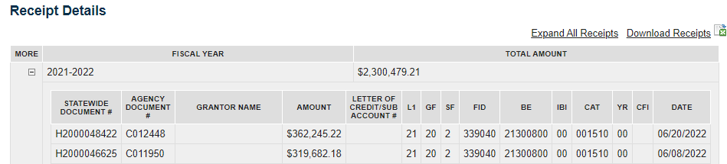

1. Disbursement contracts contain:
2. The deliverable and the related cost
3. The appropriations used for payments and obligations by fiscal year. Below is an excerpt from JAC’s 10-year lease agreement.

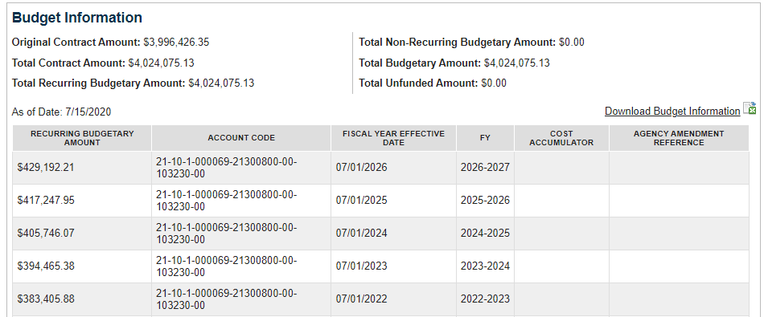

1. Payment information by fiscal year, if the contract ID is included when paid. An excerpt from JAC’s lease payments is shown below.

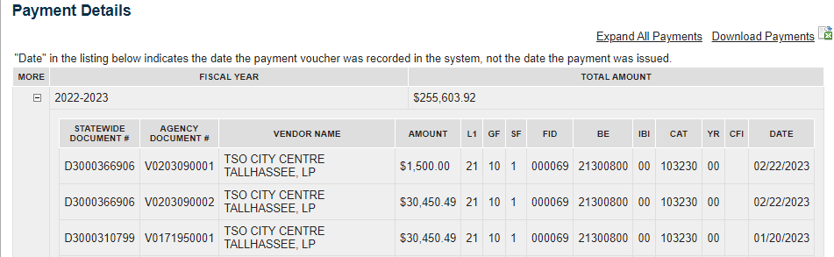

1. **How is payment or receipt information added to FLAIR? It’s automatically populated based on the following:**
   1. A FLAIR disbursement is entered containing the 5-digit contract ID. The JROs provide the contract ID on the batch sheet.

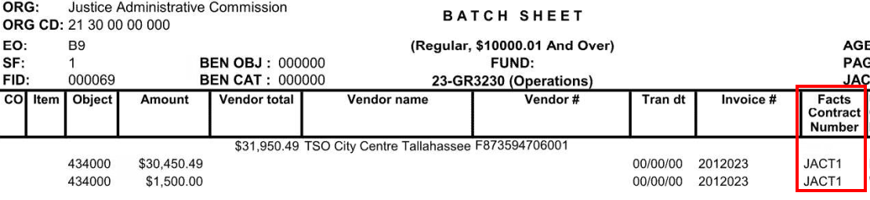

The Voucher Schedule will contain the contract ID.

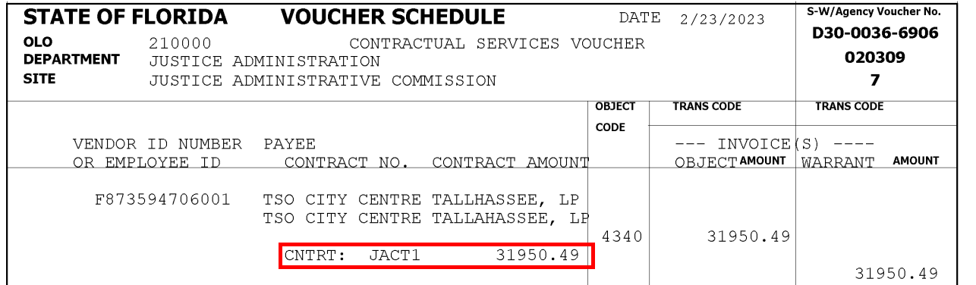

* 1. A FLAIR receipt (deposit) entry is keyed using ORG/EO, and the Grant ID can be tied to it. If the Grant ID is part of the ORG/EO setup, it will automatically be populated on deposits.

1. **How is the contract ID used in BOMS?** 
   1. The FACTS Contract number can be added to the BOMS authorization.

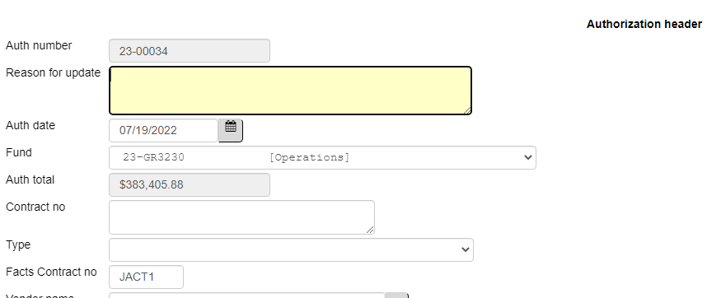

1. The ID will be printed in the Special Instructions box on the authorization.
2. The ID will automatically be added to the Invoice Header record.
   1. When populating the Invoice Header, the FACTS contract number field can also be added or updated when needed



1. **What if a batch was missing the FACT 5-digit contract ID?**
   1. For corrections needed for current fiscal year payments, notify Accounting that a correction is needed. Accounting will need the voucher number, the vendor, the FACTS contract ID, and the amount that should be added to FACTS.
   2. For corrections needed for prior fiscal year payments, discuss with Tim Tice or Dina Kamen.
2. **Why is it important to put contracts and payments in FACTS?** 
   1. The Statute requires it.
   2. DFS performs contract reviews and post-audit payment reviews.
   3. DFS reviews all payments over $10,000 and samples payments. During the DFS audit, they can refuse or delay payment if they feel FACTS is inaccurate.
3. **Additional information can be found on the** [**FAQ section of the FACTS website**](https://www.myfloridacfo.com/factshelp/facts-faq).